**Senario1 code**

conn = new Mongo("localhost:27017");

db = conn.getDB("College1");

coll = db.getCollection("section");

//Add first Sectio

doc = ({sectionID: "ISTE12301", title: "My Database Course", creditHours:"3",room:"GOL-2650",

Student: [{"uid" : "123456789", "firstName" : "Ivona", "lastName":"Bok","year":"3","mySection":"ISTE12301"},{"uid" : "234567890", "firstName" : "Ivan", "lastName":"Smith","year":"4","mySection":"ISTE12301"}]})

coll.insert(doc)

// Add second Section

doc = ({sectionID: "ISTE23401", title: "My Other Database Course", creditHours:"4",room:"GOL-2620", Student:[{"uid" : "234567890", "firstName" : "Ivan", "lastName":"Smith","year":"4","mySection":"ISTE23401"},{"uid" : "345678901", "firstName" : "Sally", "lastName":"Struthers","year":"3","mySection":"ISTE23401"}]})

coll.insert(doc)

//cursor = coll.find();

print("\nThis is the original document\n\n");

cursor = coll.find()

while (cursor.hasNext()) {

doc = cursor.next();

printjson(doc);

}

print("\nThis is the document unwound\n\n");

cursor = coll.aggregate( [ { $unwind: "$Student"}])

while (cursor.hasNext()) {

doc = cursor.next();

printjson(doc);

}

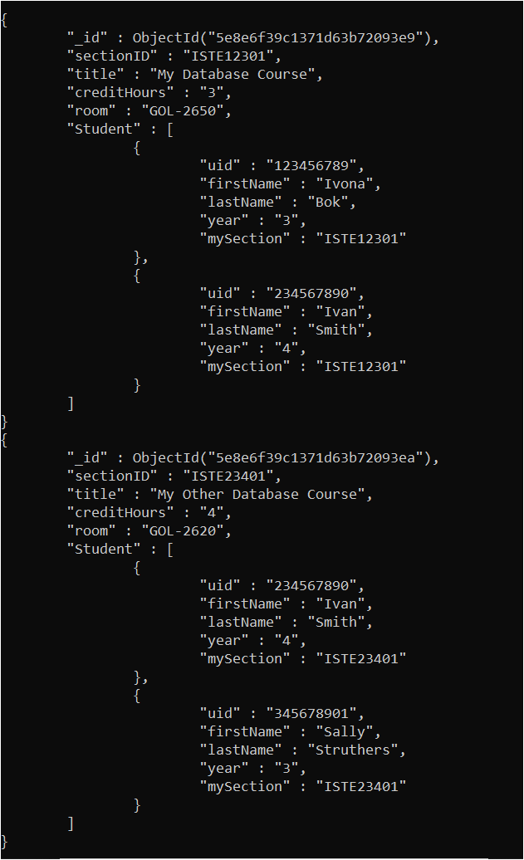

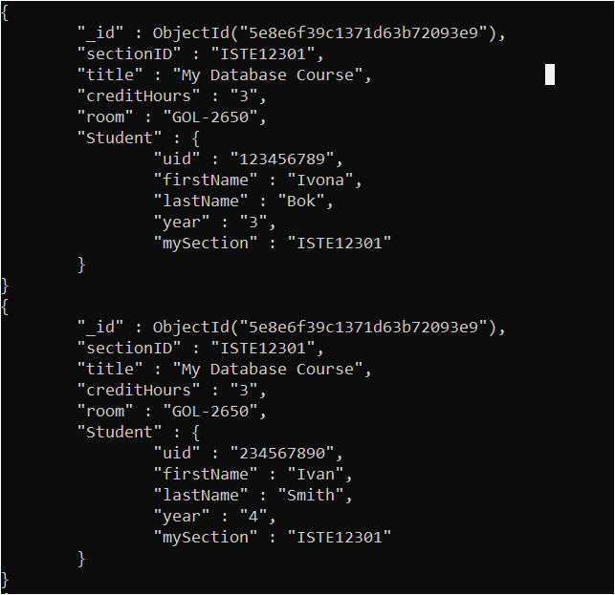

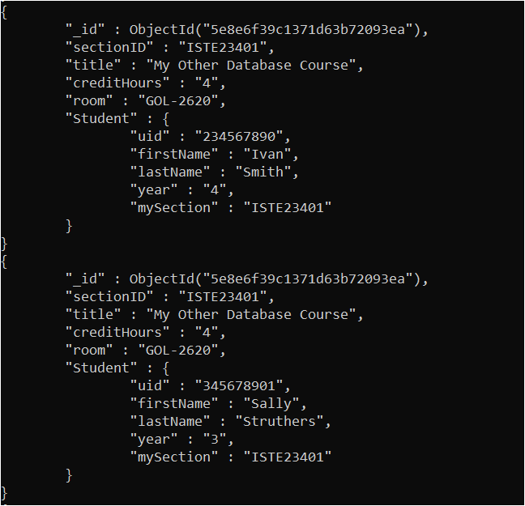

**Senario2 Code**

conn = new Mongo("localhost:27017");

db = conn.getDB("college2");

coll = db.getCollection("section");

//Add first section

var oid1 = new ObjectId()

doc = ({_id: oid1, sectionID: "ISTE12301", title: "My Database Course", creditHours:"3",room:"GOL-2650"})

coll.insert(doc)

//coll.find()

// Add second section

oid2 = new ObjectId()

doc = ({_id: oid2, sectionID: "ISTE23401", title: "My Other Database Course", creditHours:"4",room:"GOL-2620"})

coll.insert(doc)

db.section.find()

// set up student for the section

// $ref is Name of collection / $id is oid / $db is name of database

coll = db.getCollection("Student")

doc = {"section": {$ref: "section", $id: oid1, $db: "college2"}, "uid" : "123456789", "firstName" : "Ivona", "lastName":"Bok","year":"3","mySection":"ISTE12301"}

coll.insert(doc)

doc = {"section": {$ref: "section", $id: oid1, $db: "college2"}, "uid" : "234567890", "firstName" : "Ivan", "lastName":"Smith","year":"4","mySection":"ISTE12301" }

coll.insert(doc)

doc = {"section": {$ref: "section", $id: oid2, $db: "college2"}, "uid" : "234567890", "firstName" : "Ivan", "lastName":"Smith","year":"4","mySection":"ISTE23401" }

coll.insert(doc)

doc = {"section": {$ref: "section", $id: oid2, $db: "college2"}, "uid" : "345678901", "firstName" : "Sally", "lastName":"Struthers","year":"3","mySection":"ISTE23401" }

coll.insert(doc)

//Student = db.Email.findOne({"uid":/123456789/})

//dbRef = Student.section

//db[dbRef.$ref].findOne({"_id":(dbRef.$id)})

coll = db.getCollection("section");

cursor = coll.find();

while (cursor.hasNext()) {

doc = cursor.next();

printjson(doc);

}

coll = db.getCollection("Student");

cursor = coll.find();

while (cursor.hasNext()) {

doc = cursor.next();

dbRef = doc.section;

doc2 = db[dbRef.$ref].findOne({_id: dbRef.$id});

printjson(doc.uid + " "+ doc.firstName+" "+doc.lastName+" " + doc2.sectionID + " " + doc2.title);

}

**Senario 2 Output**

